**Power Bi Capstone project report**

**Problem statement**

A small company Axon, which is a retailer selling classic cars is facing issue in managing and analyzing their sales data. The sales team is struggling to make sense of the data and they do not have a centralized system to manage and analyze the data. The management is unable to get accurate and up-to-date sales reports, which is affecting the decision-making process.

**Tools required to solve the problem**

1. MySQL
2. Power BI

**Approach**

1. Firstly we get the data and load it into MySQL workbench.
2. After loading and running the data will we look into it like –

How many tables are there, what are the rows and columns it has etc.

1. Now we will connect this data with Power BI Desktop for further analyzing it.
2. We need to make a connection between workbench and Power BI.
3. After connecting we are ready to work on the dataset.
4. Since the data is new and weren’t familiar with the dataset will we click on transform data first instead of loading it.
5. After loading we find some of the columns are having null values so addressing them is the first priority.
6. After cleaning and merging different columns, we get clean data.
7. Now we will go into model building here we noticed following things
   1. The dataset follows snowflake schema instead of star schema.
   2. Customer table can be said as fact table here and rest others can be considered as dimension table.
   3. As per the good practices we will convert the snowflake schema into star schema buy expanding the columns of orders and employees.
8. After cleaning and here is the final **data model** we get like –

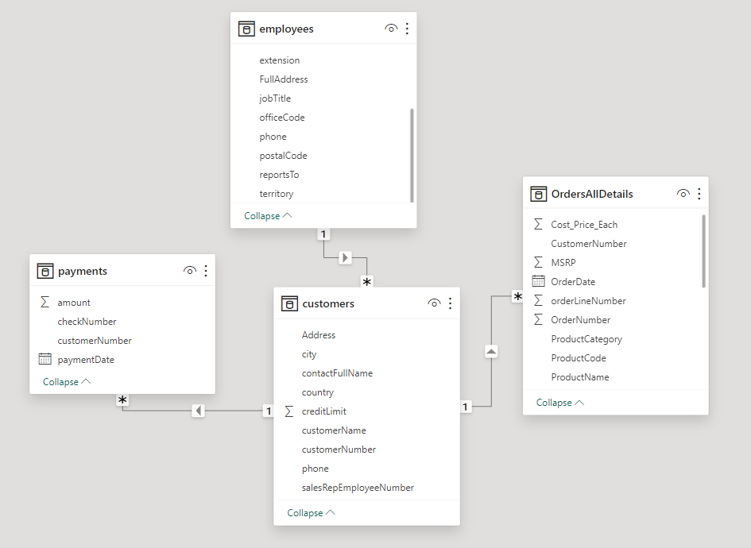

Here we can clearly see that customers table as fact table and payments, employees, OrdersAllDetails as dimension tables.

For this business problem we prepared **two dashboards**

1. Sales Dashboard
2. Order details Dashboard

**Sales Dashboard**

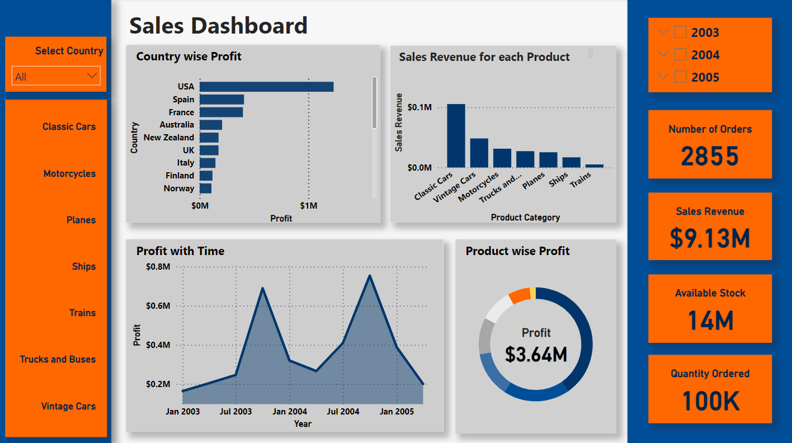

**KPIs (Key Performance Indicators)**

Now we will start preparing our dashboard for that we need some KPIs which are as follows:

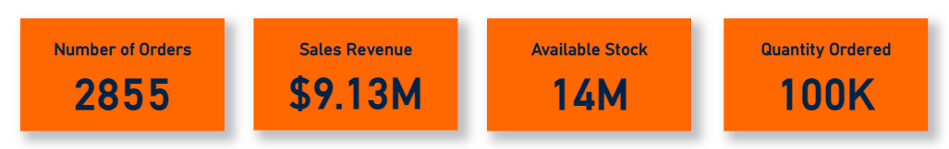

1. Number of Orders – Total number of orders placed so far
2. Sales Revenue – Units sold * Sales Price = Sales Revenue. For this we have already calculated it in power query as TotalSellingPrice for each order and applied sum of it.
3. Available Stock – This tells us total stock of items available at Axon company.
4. Quantity ordered – This tells us about the total number of quantity ordered for products as alone it doesn’t makes much sense but when we apply filters over these values they makes much more sense to us.

**Filters**

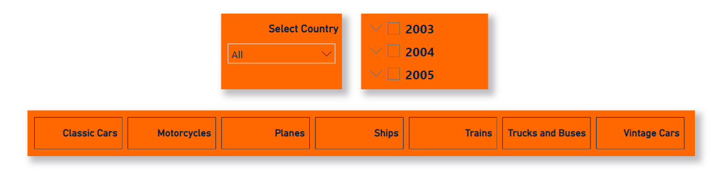

Here we have created three filters for the sales dashboard

1. Select country – It gives us the freedom to see dynamic values of KPIs and charts for each country given in the data.
2. Year -> Quarter -> Month – Using this filter we can see the dynamic values of KPIs and charts based on each yearly, quarterly or monthly basis.
3. Product Categories – Using this filter we can see values for each product on the dashboard.

**Visuals / Graphs / Plots –**

For the sales dashboard we created four different plots which are as follows:

1. **Country wise profit:**

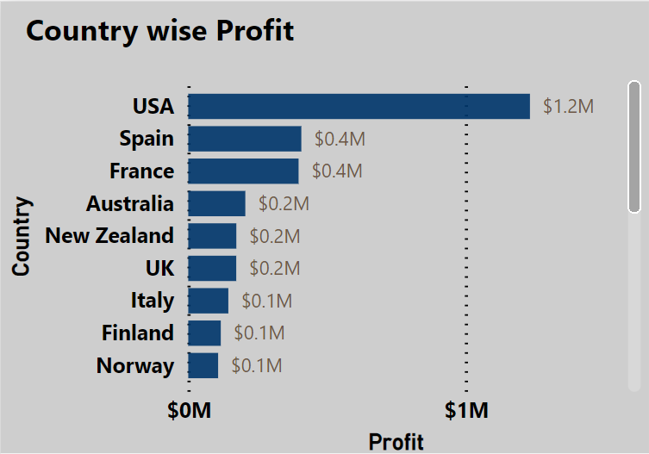

This graph tells us about the profit generated by the company in each country. Key takeaways from the graph are like

1. Axon company generates highest profit in the USA $ 1.2M.
2. Followed by Spain and France around $ 0.4M.
3. **Sales revenue for each product:**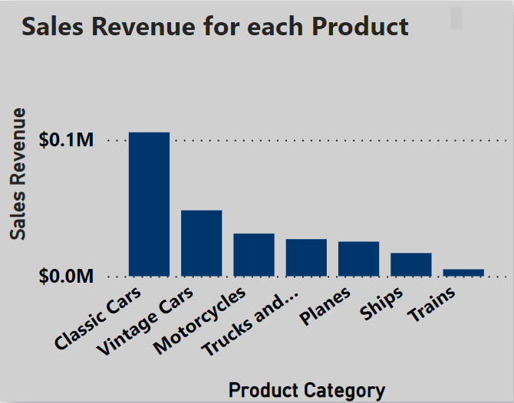

This graph gives us idea about which products gives us the highest revenue. As from the graph we can conclude that –

1. Classic cars are the major source of the revenue for the company.
2. Followed by Vintage cars.
3. Trains are the least source of revenues for the company.
4. **Profit with Time:**

In this graph we can see Yearly -> Quarterly -> Monthly wise profit which gives us a fair idea about what months of the year the company needs to focus upon. Key findings from the graph are as follows:

1. 4th quarter of both year 2003 and 2004 gives the maximum profits.
2. 1st quarter of both year 2003 and 2004 gives least profits.
3. As comparative to the year 2003 the company performed well in the year 2004.

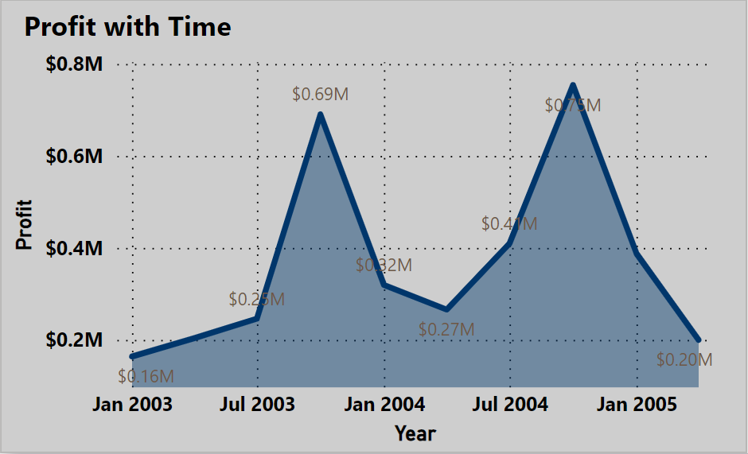

1. **Product wise profit:**

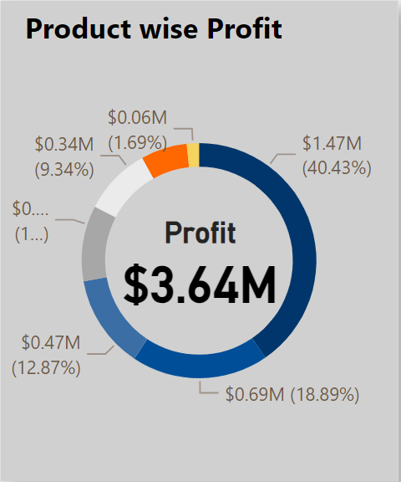

This donut chart tells us about the product wise profit contribution in total profit. Here total profit or the overall profit $3.46M is calculated using DAX measure.

From the chart we can clearly see the highest contribution in the profit is of classic cars (40.43%).

And also when we apply different-different filters then it gives us to that specific information.

**Orders Dashboard**

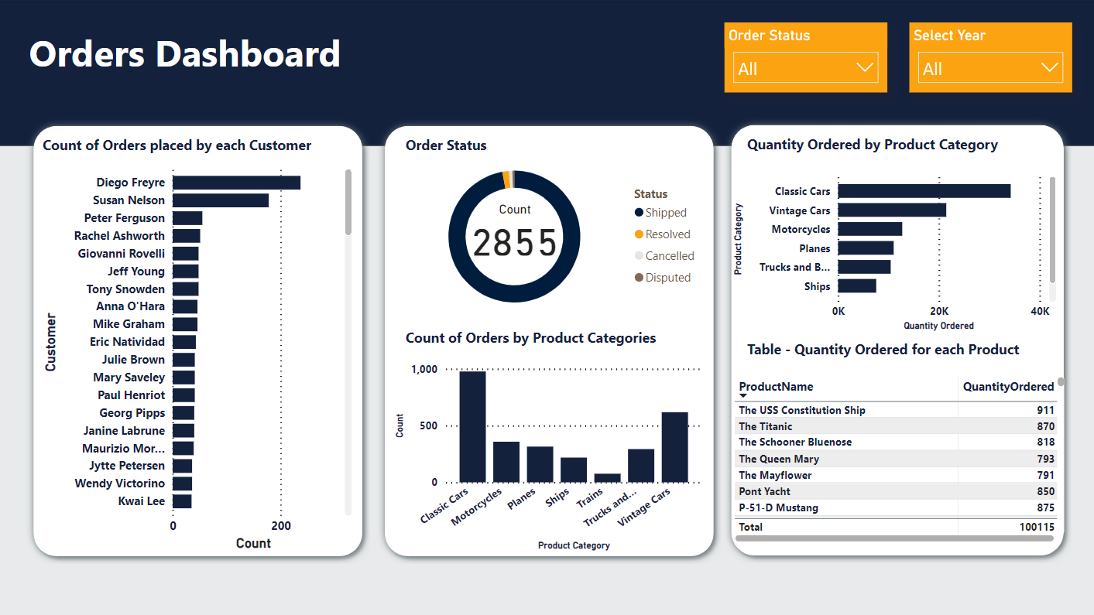

This dashboard tells us about various insights about the orders which Axon company have. To get a fair idea about sales we need to have a good knowledge of orders as well since any business key feature is how many orders it is getting and from where. Since our data contains many details about orders hence, we draw these following charts to get the insights but before that we need to focus on the filters used in this dashboard-

**Filters**

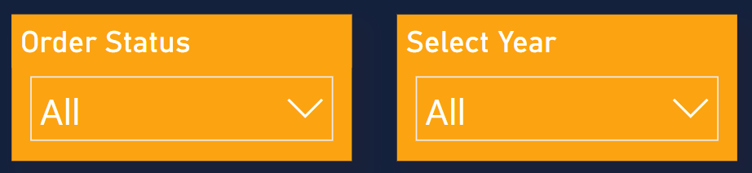

1. Order status – This filter gives us different values as per the status of the order like whether the product is cancelled, disputed, resolved, shipped or not.
2. Select year – Using this we can filter out orders on the basis of yearly, quarterly or monthly.

Now let us discuss about the graphs, card and table used in this dashboard.

**Visuals / Graphs / Plots –**

1. **Count of orders placed by each Customer:**

This graph gives us an idea about how many orders are placed by each customer. As form the graph we can see the Diego Freyre had placed highest number of orders(237).

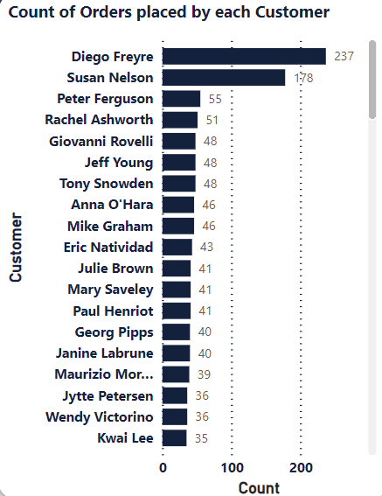

1. **Order status:**

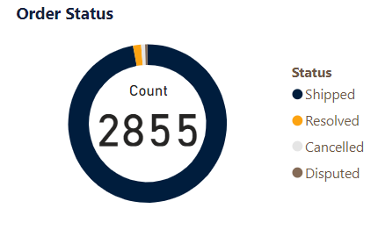

This donut chart tells us about the status as well as percentage and count(card) of orders. The chart is dynamic if we apply filter over it or just click on any of the values in the chart it gives us idea about that specific status of the order

1. **Count of orders by Product categories:**

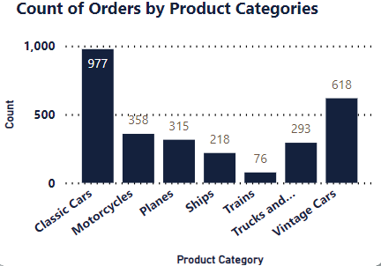

This chart tells us about the count of orders for each product. From the graph as we can see that Classic cars and Vintage Cars are highest in demand.

1. **Quantity ordered by product category:**

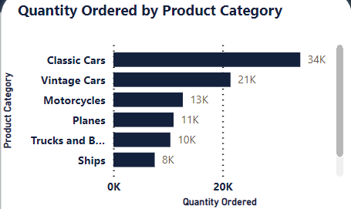

This chart tells about how much quantity of each product category is placed.

1. **Table – Quantity ordered for each Product:**

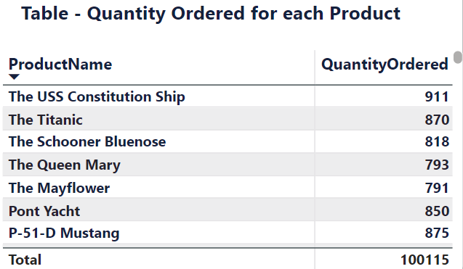

This tells us about the exact number of quantities ordered for each product available at Axon company. There are total of 100115 orders has been placed from 2003 Jan to 2005 May so far.

With these dashboards we are able to present many important insights to Axon company. And based on these dashboards they can take decisions in the future for the better growth of their company.

Project By:

Shivam Jangid

shivam1611jangid@gmail.com